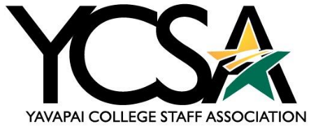

Awards Committee Meeting Notes 2024/2025

Date: October 3, 2024

Meeting Time: 3 – 3:30 pm

Note Taker: Wyatt Brannock

Call to Order: Called to order by Wyatt Brannock at 3:05 pm

Minutes:

* High-Fives
  + September had 25 high-five awards submitted.
* Retirements
  + There are no retirements pending
* Additional Items
  + No new business to discuss

Meeting Adjourned: 3:30 pm

Next Meeting: November 7, 2024

THANK YOU!