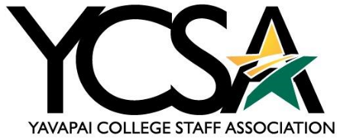

Awards Committee Meeting Notes 2024/2025

Date: December 5, 2024

Meeting Time: 3 – 3:30 pm

Note Taker: Wyatt Brannock

Call to Order: Called to order by Wyatt Brannock at 3:05 pm

Minutes:

* High-Fives
  + November had 54 high-five awards submitted.
* Retirements
  + There will be one upcoming retirement, Connie Varga
* Additional Items
  + With Connie’s replacement, YCSA seeks a new member to distribute the High Five Awards. Shannon Johns will do it in the meantime.
  + January meeting will be canceled due to Christmas / New Year

Meeting Adjourned: 3:30 pm

Next Meeting: February 6, 2025

THANK YOU!